Travelling Salesman Problem (TSP)
Aim
To implement the Travelling Salesman Problem (TSP) using Python and find the shortest possible route that visits every city exactly once and returns to the starting city.
Objective
To determine the minimum-cost tour for visiting all given cities using the Brute Force approach.
Algorithm
- Start the program.
- Enter the number of cities.
- Enter the distance between each pair of cities.
- Select the starting city.
- Generate all possible permutations of the remaining cities.
- Calculate the total distance for each possible route.
- Add the distance from the last city back to the starting city.
- Compare all route distances.
- Select the route with the minimum total distance.
- Display the shortest route and minimum distance.
- Stop the program.

Flowchart
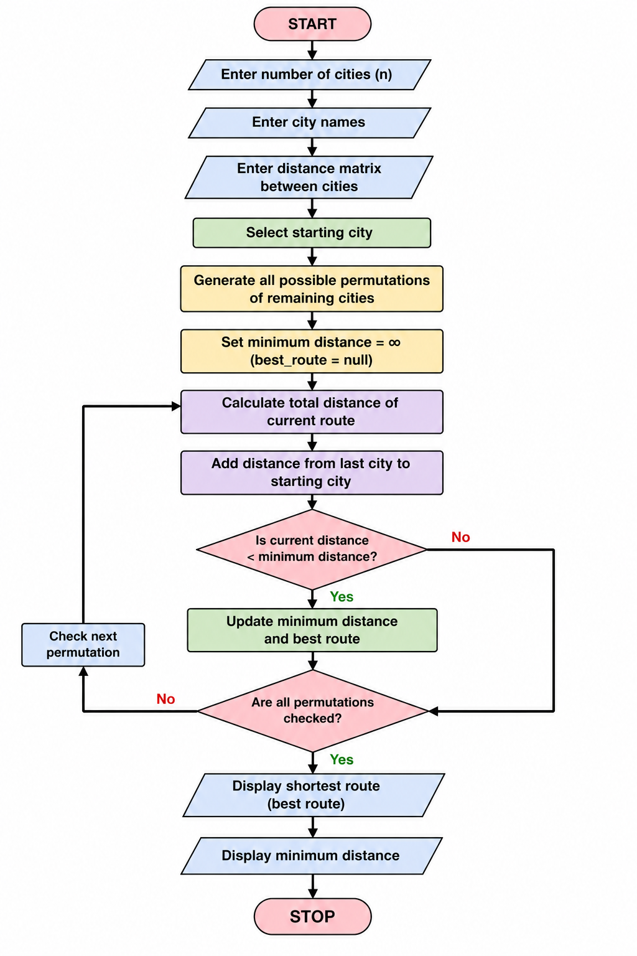
Python Code
from itertools import permutations

n = int(input("Enter number of cities: "))

cities = []

for i in range(n):
city = input("Enter city name: ")
cities.append(city)

distance = []

print("Enter distance matrix:")

for i in range(n):
row = list(map(int, input().split()))
distance.append(row)

start = 0
min_distance = float('inf')
best_route = None

remaining_cities = list(range(1, n))

for route in permutations(remaining_cities):
current_route = [start] + list(route) + [start]
total_distance = 0

for i in range(len(current_route) - 1):
total_distance += distance[current_route[i]][current_route[i + 1]]

if total_distance < min_distance:
min_distance = total_distance
best_route = current_route

print("\nShortest Route:")

for i in best_route:
print(cities[i], end=" -> ")

print("\nMinimum Distance:", min_distance)

Output
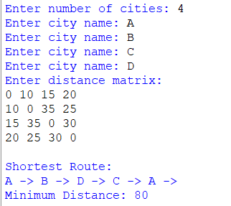
Result
The Travelling Salesman Problem was successfully solved using the Brute Force method, and the shortest route with the minimum travelling distance was obtained.
Conclusion
The program successfully finds the optimal route for the Travelling Salesman Problem by generating all possible routes and selecting the route with the minimum total distance.

